ONLINE FOOD SERVICE PAYMENTS NOW AVAILABLE!

The Morris County School District now provides parents an easy and convenient way to make food service payments. Parents may pay with VISA, MasterCard or Discover credit or debit cards. Our Web Store accepts payments over the internet 24/7. By contracting with RevTrak, a national credit card payment processor, we provide you a secure site for making payments.

Parents can make payments online while on their home or work computer, any time of the day. It only takes a few minutes to make a payment using a VISA, MasterCard or Discover credit or debit card. The convenience of paying online is further enhanced when parents access the Web Store and see a familiar shopping cart (just like shopping online.)

To make an online payment follow these simple steps:

- Visit our district website at http://www.usd417.net
- Click Online Payment link
- Select Food Service Payments, and enter your PowerSchool Portal Account login credentials
- Enter amount under Add Funds and select Next Page
- Make payment using a VISA, MasterCard or Discover debit or credit card

A payment receipt will be emailed to the address used when setting up the web store account. To view/print previous online payments or to update login information please click on My Account.

Please Visit the Morris County School District Website for Future Updates!

USD 417
17 South Wood Street
Council Grove, KS 66846

Please see reverse side for detailed online payment instructions.
Payment Instructions for the USD 417 Web Store

- Visit school district website at http://www.usd417.net/

- Click Online Payment link

- Redirect to Morris County USD 417 Web Store, Select Food Service Payments

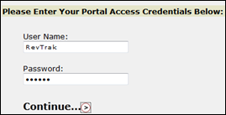

- Enter your PowerSchool Portal Account credentials

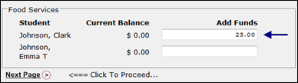
- Enter amount under Add Funds for each student (if applicable)

- Select Next Page

- When all payments are in shopping cart, click Go to Checkout.

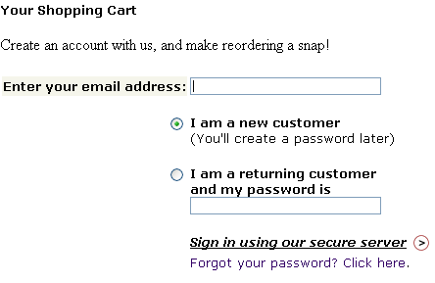
- If a new customer, select I am a new customer. Enter your email address and Sign In. If a returning customer, select I am a returning customer. Enter your email address and password. Select Sign In.

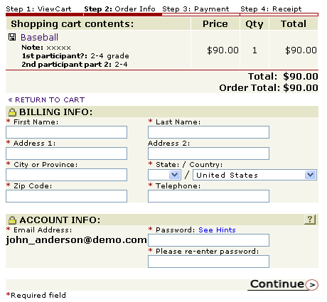
- Enter your billing and payment information. Create a password if required.

- Verify information for accuracy and select Complete Order.

- Payment will be processed and receipt can be viewed and printed. A receipt will be sent to the email address provided during account set up.

- Logout

